

**Product Dissection for Flipkart**

**Project Type -** Product Dissection

**Contribution -** Individual

**Video link-** [product disection.mp4](https://drive.google.com/file/d/1KVnMyxonbI0vxZ5iFwU01FFRYfyjATD8/view?usp=sharing)

**Company Overview:**

Flipkart was founded in 2007 by Sachin Bansal and Binny Bansal. It is a prominent e-commerce platform based Company in Bangalore, India. In Initial days it was focused on selling books but as the rapid expansion of the company its product offerings included a wide range of categories such as electronics, fashion, home essentials, and groceries. It is Known for its robust marketplace model and operates with a blend of third-party seller listings and its own private label products.

In 2018 Flipkart was Acquired by Walmart. Its Algorithms provide a seamless shopping experience with features like real-time tracking and personalised recommendations. It Primarily serves the Indian market, which is its core region.

As a major player in India’s e-commerce landscape, Flipkart continues to drive innovation and adapt to the evolving digital retail environment. Its markate in India include major cities such as Bangalore, Mumbai, Delhi, Chennai, Hyderabad, and Kolkata in urban areas and it has also made substantial efforts to reach rural consumers by expanding its delivery network. From the current data it has approximately 400 million registered users.

**Product Dissection and Real-World Problems Solved by Flipkart:**

Flipkart as an Indian e-commerce platform has effectively addressed real world problems through innovative product offerings. It provides a large range of products including various varieties. Let's dissect some of the key aspects of Flipkart's operations and the problems it has solved:

**Online Shopping Platform:** Flipkart provides a user-friendly online platform that enables customers to browse and purchase a wide range of products, from electronics to fashion, groceries, and more. This platform addresses several problems: product, searchins, filtering etc.

**Convenience:** Flipkart offers customers the convenience of shopping from the comfort of their homes, eliminating the need for physical store visits.

**Accessibility:** It brings products from various brands and sellers to customers in even remote areas of India, thereby addressing the issue of limited access to quality products. Price

**Comparison:** Flipkart allows customers to compare prices and read reviews, empowering them to make informed purchasing decisions.

**Supply Chain and Logistics**: Flipkart has invested heavily in building a robust supply chain and logistics network. This addresses challenges related to efficient product delivery, including last-mile delivery in India's diverse geography.

**Efficient Delivery:** Flipkart's logistics network ensures timely and efficient delivery, reducing the wait time for customers.

**Payment Solutions:** Flipkart offers various payment solutions, including digital wallets and EMI options, to cater to diverse customer needs. By providing EMI options, Flipkart makes high-value products more affordable, addressing financial inclusion issues. In a market where many customers prefer cash transactions, Flipkart pioneered cash-on-delivery (COD) options, increasing trust and convenience.

**Digital Payments**: It promotes the adoption of digital payments, contributing to the digitization of the economy.

**Marketplace and Seller Ecosystem:** Flipkart has created a marketplace that allows third-party sellers to list their products, boosting entrepreneurship and addressing employment issues.

**Job Creation**: The platform has created job opportunities for sellers, delivery personnel, and customer support staff.

**Entrepreneurship:** It has enabled many small and medium-sized businesses to reach a wider audience and grow their operations.

**Technology and Innovation:** Flipkart continually invests in technology and innovation to enhance user experience and solve logistical challenges.

**Conclusion:**

Flipkart has transformed online shopping in India by offering a user-friendly e-commerce platform that simplifies product search and filtering. It enables convenient home shopping with access to a broad range of products, even in remote areas. The platform supports informed buying through price comparisons and customer reviews. Significant investments in supply chain and logistics ensure timely delivery, while diverse payment options, including EMI and cash-on-delivery (COD), enhance financial inclusion and promote digital payments. Flipkart’s marketplace model boosts entrepreneurship and job creation, driving business growth across sectors. Through ongoing technological innovations, Flipkart improves user experience and addresses real-world challenges, solidifying its leadership in the Indian e-commerce market.

**Case Study on the real world problems and approach to solving them**

Flipkart is a major online shopping site in India that has changed the way people shop. It has tackled several big problems with clever solutions. Here’s how Flipkart deals with these issues and the effects it has:

**Problem 1: Limited Access to Quality Products**

* **Problem**: In many parts of India, especially in rural areas, it was hard to find good-quality products.
* **Solution**: Flipkart brought together many different products from various brands and sellers on its website. This made it easier for people everywhere in India to find and buy quality items.
* **Impact**: More people, both in cities and rural areas, could access the products they needed.

**Problem 2: Delivery Challenges**

* **Problem**: Getting products to people, especially in remote areas, was often slow and difficult.
* **Solution**: Flipkart invested in building a strong delivery system and started offering cash-on-delivery (COD) as a payment option.
* **Impact**: Deliveries became faster and more reliable, and COD made it easier for people who prefer to pay with cash.

**Problem 3: Financial Barriers**

* **Problem**: Many people couldn’t afford expensive items all at once.
* **Solution**: Flipkart introduced EMI (Equated Monthly Instalments) options, allowing customers to pay for expensive products in smaller, monthly payments.
* **Impact**: This made it easier for more people to buy high-value products.

**Problem 4: Creating Jobs and Supporting Small Businesses**

* **Problem**: There were issues with unemployment and people needing more job opportunities.
* **Solution**: Flipkart created a marketplace for third-party sellers, which helped generate jobs for delivery workers, customer service staff, and others.
* **Impact**: More jobs were created, and small businesses had a chance to grow and reach more customers.

**Problem 5: Technology and Environmental Concerns**

* **Problem**: Traditional shopping was often inefficient, and there were growing environmental concerns.
* **Solution**: Flipkart used technology like AI for better recommendations and improved delivery processes. It also worked on using sustainable packaging to reduce its environmental impact.
* **Impact**: The use of technology made shopping easier and more efficient, and the sustainability efforts showed Flipkart’s commitment to the environment.

**Conclusion:**

Flipkart’s growth from a small startup to a top e-commerce company shows how it has solved real-world problems with smart solutions. By improving product access, delivery, affordability, job opportunities, and environmental responsibility, Flipkart has made a big difference in online shopping and has helped with economic and social development in India. This case study shows how businesses can positively impact society and still succeed in a competitive market.

**Schema Design Based on Top Features**

**Top Features of Flipkart:**

1. **Product Search and Browsing**: Users can search for and browse a vast catalogue of items across various categories like electronics, fashion, and home appliances.
2. **User Accounts**: Customers can create accounts to save preferences, track orders, and manage addresses and payment methods.
3. **Product Reviews and Ratings**: Users can read and write reviews and rate products, helping others make informed decisions.
4. **Wishlist**: Users can add products to their Wishlist for future reference or purchase.
5. **Secure Payment Options**: Multiple payment options are available, including credit/debit cards, digital wallets, UPI, and cash on delivery (COD).
6. **EMI and Financing**: EMI options and financing are available for high-value purchases, making them more affordable.
7. **Order Tracking**: Customers can track their orders in real-time, from processing to shipping and delivery.
8. **Seller Dashboard**: Sellers have a dedicated dashboard to manage product listings, inventory, pricing, and order fulfilment.
9. **Customer Support**: Flipkart offers support through chat, email, and phone for inquiries, returns, and concerns.
10. **Deals and Discounts**: Various deals, discounts, and offers are available, especially during festive seasons and sales events.
11. **Mobile App**: A user-friendly mobile app allows convenient shopping on smartphones and tablets.

**Schema Description:**

**User Entity**

* **User ID (Primary Key): Unique identifier for each user.**
* **Username: User’s chosen name.**
* **Email: User’s email address.**
* **Password: User’s password (stored securely).**
* **Phone Number: User’s contact number.**

**Product Entity**

* **Product ID (Primary Key): Unique identifier for each product.**
* **Name: Name of the product.**
* **Description: Description of the product.**
* **Category: Category the product belongs to (e.g., electronics, fashion).**
* **Price: Price of the product.**
* **Average Rating: Average rating of the product based on user reviews.**

**Order Entity**

* **Order ID (Primary Key): Unique identifier for each order.**
* **User ID (Foreign Key): References the User who placed the order.**
* **Order Date: Date when the order was placed.**
* **Status: Current status of the order (e.g., Processing, Shipped, Delivered).**

**Payment Entity**

* **Payment ID (Primary Key): Unique identifier for each payment.**
* **Order ID (Foreign Key): References the Order for which payment was made.**
* **Payment Date: Date when the payment was made.**
* **Payment Method: Method used for payment (e.g., Credit Card, COD, Wallet).**

**Review Entity**

* **Review ID (Primary Key): Unique identifier for each review.**
* **User ID (Foreign Key): References the User who wrote the review.**
* **Product ID (Foreign Key): References the Product being reviewed.**
* **Rating: Rating given by the user.**
* **Review Text: Text of the review.**
* **Review Date: Date when the review was written.**

**Wishlist Entity**

* **Wishlist ID (Primary Key): Unique identifier for each wishlist item.**
* **User ID (Foreign Key): References the User who created the wishlist.**
* **Product ID (Foreign Key): References the Product added to the wishlist.**
* **Date Added: Date when the product was added to the wishlist.**

**Seller Entity**

* **Seller ID (Primary Key): Unique identifier for each seller.**
* **Seller Name: Name of the seller.**
* **Seller Email: Seller’s email address.**
* **Seller Phone Number: Seller’s contact number.**

**Inventory Entity**

* **Inventory ID (Primary Key): Unique identifier for each inventory record.**
* **Seller ID (Foreign Key): References the Seller who owns the inventory.**
* **Product ID (Foreign Key): References the Product in inventory.**
* **Quantity: Number of units available in stock.**
* **Price: Selling price of the product in the inventory.**

**ER Diagram**

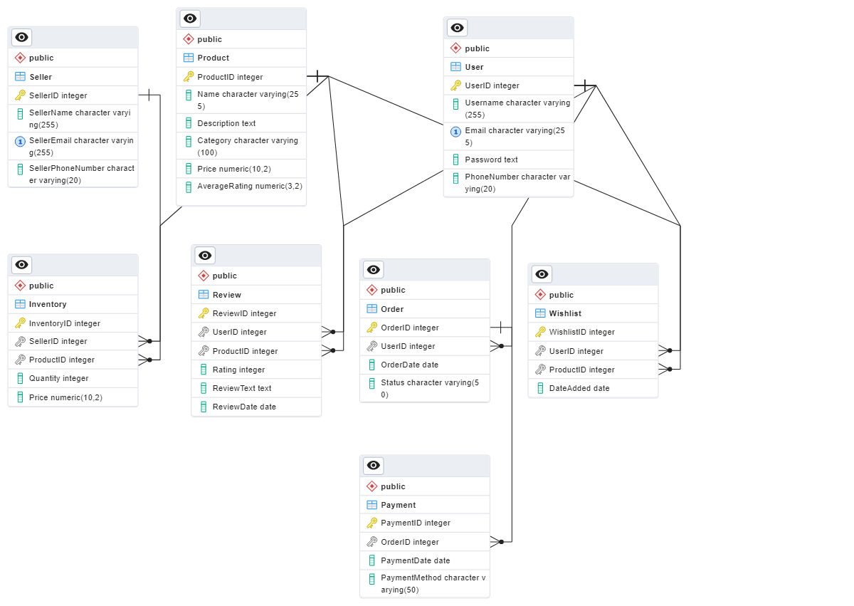

In this diagram:

* User, Product, Seller, Order, Payment, Review, and Wishlist are the entities.
* The lines connecting the entities represent relationships between them.
* User ID, Product ID, Seller ID, Order ID, Payment ID, and Review ID are the primary keys of their respective entities

**Findings or Conclusion**

Flipkart is a major e-commerce player, benefiting both shoppers and businesses. It offers a platform for entrepreneurs to reach a wide audience and makes shopping easy and enjoyable with features like smart deal recommendations, real-time order tracking, and secure payment options. EMI and cash-on-delivery options enhance accessibility. Flipkart stays ahead in the Indian market by continually improving its technology and services.

The schema for Flipkart organises data using entities like `User`, `Product`, `Order`, `Payment`, `Review`, and `Wishlist`, ensuring efficient management. Good schema design ensures the platform runs efficiently and provides a seamless, enjoyable experience for users by minimising delays and improving responsiveness. For example, `Product` supports search and browsing, while `Order` and `Payment` manage transactions. `Review` and `Wishlist` enhance user experience, and `Seller` and `Inventory` handle listings and stock.